Address
Bioinformatics Laboratory
Room J1b-208 (J-building, floor 1B, room 208)
++31-(0)20-5667096
a.h.vankampen@amsterdamumc.eu
Amsterdam University Medical Centers
Location: Academic Medical Center (AMC)
Meibergdreef 9
1100 DE Amsterdam
the Netherlands

How to get to us?
Train. Disembark at the Amsterdam Central Station, Amstel station, or Station Bijlmer (closest to AMC) and change to the metro direction Gein (50 or 54).

Train from Schiphol Airport. Take the train to (metro) station ‘Amsterdam Bijlmer Arena’ (15 minutes) and take metro.

Metro. From Central Station or Amstel Station take metro 54 in direction ‘Gein’. From station Bijlmer Arena take any metro (50 or 54 direction Gein). Disembark at station Holendrecht.

From (metro) station Holendrecht to AMC. From the metro station it takes a few minutes to walk to the AMC (you will see the AMC from the station). You can either go to the main entrance (see map below), or take the walkway to the faculty entrance which will take you directly to the J-building in which the Bioinformatics Laboratory is located.

For more information see:
https://www.amc.nl/web/over-de-locatie-amc/organisatie/adres-route-en-parkeren.htm

Metro Map

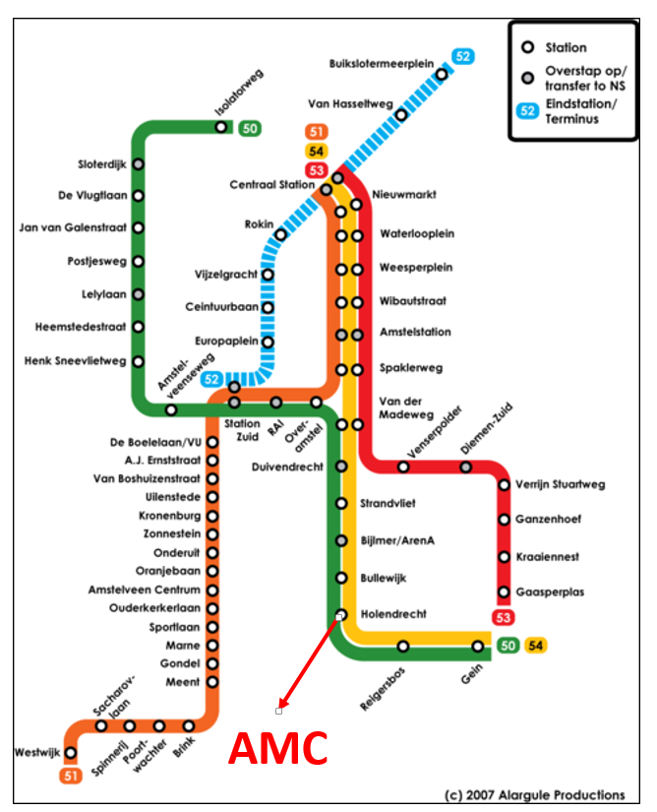

Map of AMC

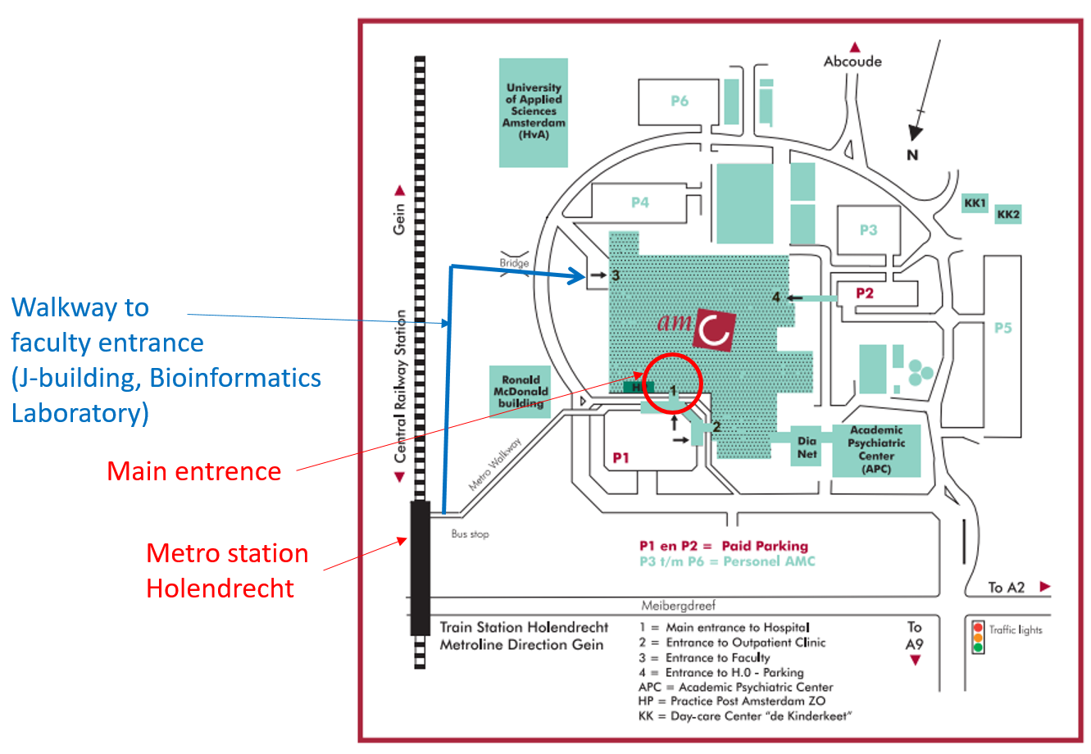

AMC Buildings

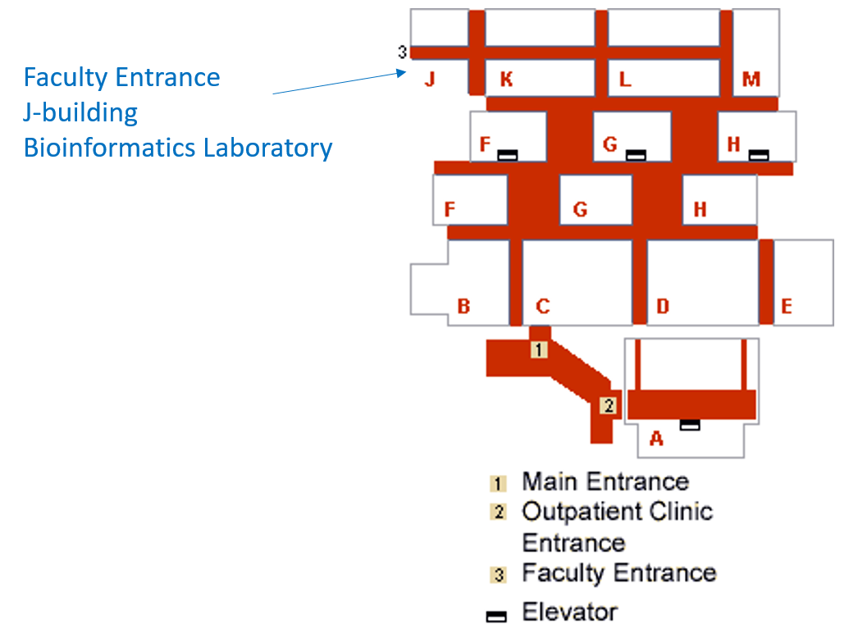

AMC Faculty Entrance

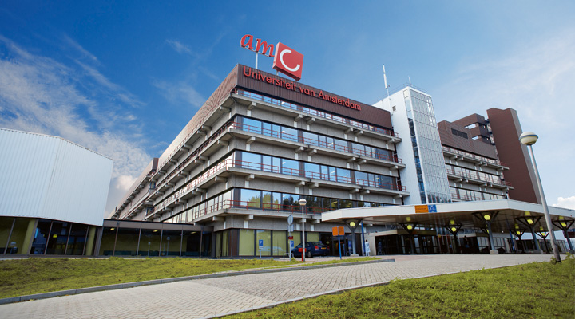

AMC Google Maps

https://goo.gl/wE7Mcw

